Justin Casteel

July 9, 2016

CMIS 242 6382 Intermediate Programming

Project 4

**My approach:**

My approach on this project was to keep the user informed as to what is going on. What I mean by this is to use many dialog boxes to keep the user in the loop about what is happening while using the program. This also includes any errors that may be happening in the program, I didn’t want the user to have to question anything at all, but let the program do the work for them. I wanted to keep the GUI simple and clean for the user and have everything easy to manage and understand. In my code I used mainly if/else statements which I thought would be perfect for this type of project because it gave me plenty of opportunities to interact with the user and to execute the code properly and also have it displayed properly to the user as well so the user wouldn’t be confused or have questions unanswered.

**Lessons learned:**

The biggest lesson that I have learned from this entire project was how to keep my code organized so it’s easily readable and easy to find specific parts I need when working on it. The way that I went about doing this project required a lot of calling to methods based upon which choice was selected by the user. In my opinion I thought that this would the best object oriented approach and would keep things much cleaner and organized. For example, the user chooses the find option from the drop down menu, then the code would tell it to drop down to the method which corresponds to that selection. While coding this project I learned to always keep the question, “If I give my code to someone else, will they understand it like I do?”, and this really kept me on my toes and organized throughout the creation process. If someone else comes across my code and they don’t understand a specific part of it, then I have failed them and I didn’t want that to happen. I hope that I have accomplished this and have definitely improved on my techniques and organizations skills because of this project alone.

**Possible Improvements:**

One thing that I could definitely improve on in this project would be to not reuse code as much as I did. For example, in each of the combobox options I started each one off checking if the id entered was a number less than zero. I am sure that I could have one call that would check this before even getting down to the method that corresponds with the selection made and this alone would clear up a lot of extra lines of code. The same improvement that could be made just like the id checking would be if the student already existed in the database. Instead of having a ton of if else statements with joptionpane message dialog boxes I may have been able to check this using one method for the entire project instead of having the same code reused in each method and cluttering up the methods with unneeded text.

**UML Diagram:**

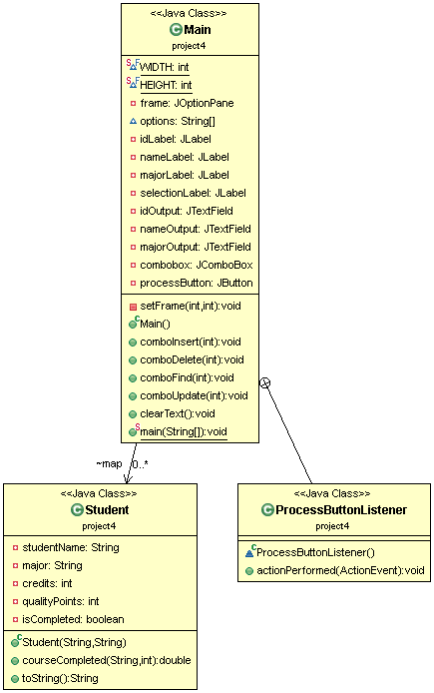

**Test Plan:**

The GUI shown to the user upon executing the program.

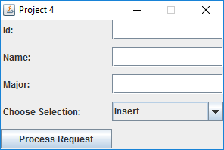

Entering a new student into the database via the Insert combobox selection.

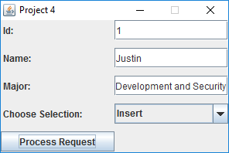

The message shown once clicking the process request button.

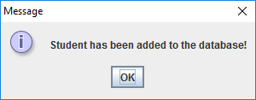

Using the Find option in the jcombobox to find the user we have just entered.

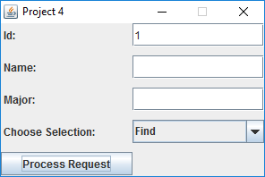

The message box displayed when the user clicks the process request button.

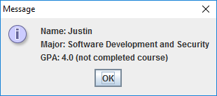

Error message shown when the user id entered is not found in the hashmap using the Find combo box option. This same message is shown when the delete button is used on an id that is not found in the hashmap.

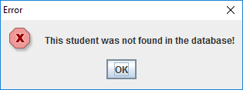

Using the Update option in the jcombobox to update the credits and grade of the id entered.

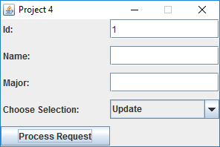

The first dialog box that prompts the user for a grade once hitting the process request button. The initial grade selected is “A”, I have chosen “C” in this case for the grade. The user can choose between A, B, C, D, and F from the combo box as the grade.

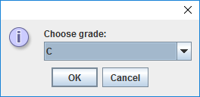

The second dialog box that prompts the user for the credits once hitting the process request button. The initial credits selected is “3”, I have chosen “6” in this case for the grade. The user can choose between 3 and 6 credits from the drop down menu.

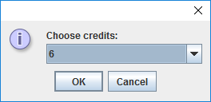

The message box displaying the new GPA of the student after updating the credits and grade using the Find combo box selection.

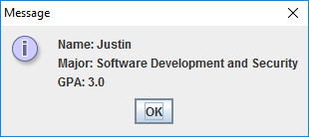

The message shown when the user has not had their grade and credits updated yet in the database.

